35 Years After Addressing Congress, James Hansen Has More Climate Warnings
The former NASA scientist James Hansen says in a new paper that global temperatures will pass a major milestone this decade, faster than other estimates predict.
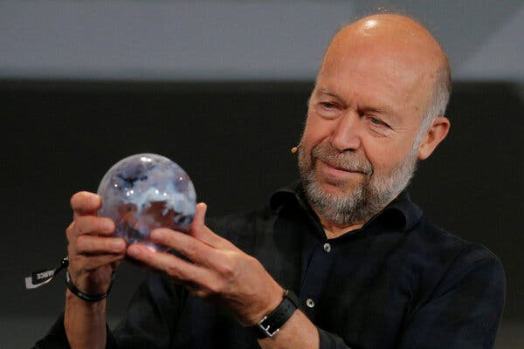
James Hansen in 2017. “The 1.5 degree limit is deader than a doornail,” he said recently. Credit...Brian Snyder/Reuters
By Delger Erdenesanaa, Published Nov. 2, 2023Updated Nov. 3, 2023

Global warming may be happening more quickly than previously thought, according to a new study by a group of researchers including former NASA scientist James Hansen, whose testimony before Congress 35 years ago helped raise broad awareness of climate change.
The study warns that the planet could exceed 1.5 degrees Celsius, or 2.7 degrees Fahrenheit, of warming this decade, compared with the average temperature in preindustrial days, and that the world will warm by 2 degrees Celsius by 2050. When countries signed the landmark Paris Agreement in 2015 to collectively fight climate change, they agreed to try and limit global warming to “well below” 2 degrees Celsius and aim for 1.5 degrees.
“The 1.5 degree limit is deader than a doornail,” said Dr. Hansen, now the director of the Climate Science, Awareness and Solutions Program at Columbia University, during a news conference on Thursday. The 2 degrees goal could still be met, he said, but only with concerted action to stop using fossil fuels and at a pace far quicker than current plans.
The world has warmed by about 1.2 degrees Celsius so far and is already experiencing worsening heat waves, wildfires, storms, biodiversity loss and other consequences of climate change. Past the Paris Agreement temperature goals, which reflect the results of international diplomacy rather than exact scientific benchmarks, the effects will get significantly worse and veer into territory with greater extremes and unknowns.
Experts generally don’t quibble over the finding that the planet will soon pass 1.5 degrees of warming. A separate study published on Monday by British and Austrian scientists similarly found that, at our current rate of burning fossil fuels, the world would be committed to passing 1.5 degrees of warming within six years.

Latest News on Climate Change and the Environment
Dire warnings. Global warming may be happening more quickly than previously thought, according to a new study by a group of researchers including former NASA scientist James Hansen, whose testimony before Congress 35 years ago helped raise broad awareness of climate change.
Aid for climate shocks. Wealthy countries have decreased the amount of money they commit for helping developing countries cope with the effects of climate change, even as the need for that spending has grown, the U.N. said in a report. Aid for climate adaptation fell to $21 billion in 2021, the latest year for which comprehensive data is available, a drop of 15% from 2020.
A peak in fossil fuel use? For more than a century, the world’s appetite for fossil fuels has been expanding relentlessly. But the International Energy Agency now predicts that global demand for oil, natural gas and coal will peak by 2030, partly driven by policies that countries have already adopted to promote cleaner forms of energy and transportation.
Atlantic hurricanes. Hurricanes in the Atlantic Ocean are now twice as likely to grow from a weak storm into a major Category 3 or higher hurricane within just 24 hours, according to a new study. When hurricanes intensify so quickly, it may become more difficult to make predictions and prepare for disaster.
On the brink. The Amazon rainforest, where a fifth of the world’s freshwater flows, is reeling from a powerful drought that shows no sign of abating. Likely made worse by global warming and deforestation, the drought has fueled large wildfires that have made the air hazardous for millions of people, while also drying out major rivers at a record pace.
“I think everyone agrees that 1.5 degrees is in the rearview mirror at this point,” said Zeke Hausfather, a research scientist at Berkeley Earth.
What Dr. Hausfather and others disagree with is the Hansen team’s estimate of just how sensitive the Earth’s climate is to greenhouse gases, and accordingly, how soon the world might pass 2 degrees of warming.
The new study analyzed reconstructed temperatures and carbon dioxide levels over the past 66 million years, using evidence from other recent papers, to calculate a numerical relationship between carbon dioxide and temperature. Global warming is being driven by the burning of fossil fuels, which releases greenhouse gases like carbon dioxide into the atmosphere, where it traps the sun’s heat, warming the planet.
The researchers found that if the amount of carbon dioxide in the atmosphere is doubled, the planet will warm by somewhere between 3.6 and 5 degrees Celsius.
“That is very much on the high end of the range of estimates that are in the academic literature today,” Dr. Hausfather said.
A 2021 report from the Intergovernmental Panel on Climate Change, which Dr. Hausfather contributed to, estimated that doubling carbon dioxide from preindustrial levels would result in warming between 2 and 5 degrees Celsius, mostly likely around 3 degrees. The IPCC report combined many different estimates that scientists have arrived at using various methods, including climate models, historical data and reconstructions of Earth’s distant past.
So far, humans have increased the amount of carbon dioxide in the atmosphere by about 50 percent, from 280 parts per million in the 1700s to 417 parts per million in 2022 — resulting in a relatively linear temperature increase over time. But Dr. Hansen believes warming is accelerating.
One reason, he said, is a successful reduction in sulfate aerosols in the atmosphere as countries and industries, especially shipping, have cracked down on air pollution in recent years. Different pollutants have different effects in the atmosphere. Sulfate aerosols, another byproduct of burning fossil fuels, reflect sunlight away from the surface of the Earth and help cool the planet slightly.
Window for Meeting Key Climate Goal Is Even Narrower Than Thought
Other prominent climate scientists, including Michael Mann at the University of Pennsylvania, who published a rebuttal of the new study, disagree that climate change is accelerating.
Despite these disagreements, the very real, physical deadlines of 1.5 and 2 degrees Celsius are looming close enough on the horizon that, to a certain extent, exactly how sensitive the Earth’s climate is to future greenhouse gas emissions doesn’t matter. Most experts agree that while the 1.5 degree goal has already been missed, 2 degrees is still salvageable — but not without much more action than countries are currently taking.
“We’re also going to pass 2 degrees. That’s clear, unless we take action to reduce the energy imbalance,” Dr. Hansen said. “The first thing we must do is reduce emissions as fast as possible.”
Have Climate Questions? Get Answers Here.
What’s causing global warming? How can we fix it? This interactive F.A.Q. will tackle your climate questions big and small.

A correction was made on Nov. 3, 2023: An earlier version of this article described incorrectly the findings of a study published on Oct. 30 by British and Austrian researchers. Their study found that, under current conditions, Earth has about six years before it is committed to passing 1.5 degrees of warming, not that Earth is likely to pass 1.5 degrees of warming within six years.

