Gulf Stream Could Collapse Between 2025 and 2095, Bringing Disastrous Climate Impacts, Study Finds

By: Cristen Hemingway Jaynes
Published: July 26, 2023
Edited by Chris McDermott
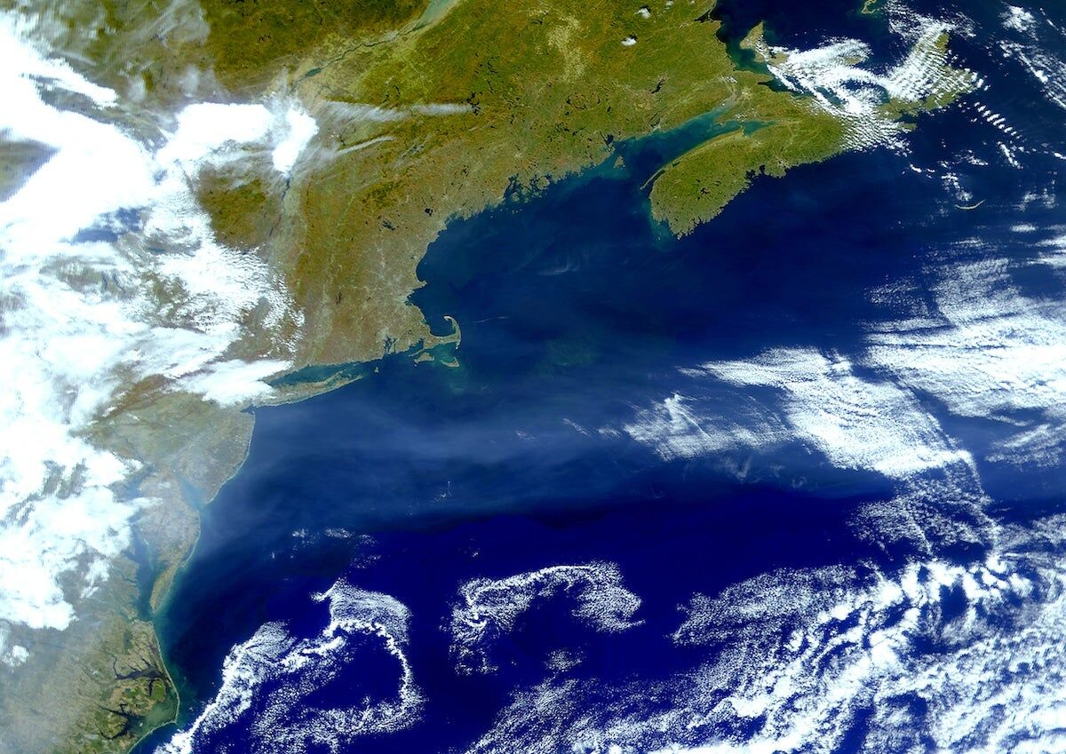
Satellite image of the Gulf Stream taken in 2000 using LANDSAT data. Planet Observer / Universal Images Group via Getty Images
Why you can trust us
The Gulf Stream is a strong current of warm water that flows from the Gulf of Mexico into the Atlantic Ocean, and runs from the East Coast of the United States across the Atlantic and north past Western Europe. Without the Gulf Stream, which is part of the Atlantic Meridional Overturning Circulation (AMOC), a system of ocean currents that is vital to Earth’s climate, places like England would be much colder.
A new study by Susanne Ditlevsen and Peter Ditlevsen, researchers with the University of Copenhagen in Denmark, has concluded that the AMOC is at risk of collapsing around mid-century, much earlier than scientists had previously thought.
“The Atlantic meridional overturning circulation (AMOC) is a major tipping element in the climate system and a future collapse would have severe impacts on the climate in the North Atlantic region,” the authors wrote in the study. “We estimate a collapse of the AMOC to occur around mid-century under the current scenario of future emissions.”
In the study, the researchers conclude that there is a 95 percent probability that “a transition of the AMOC” will happen around 2025 to 2095.
Consistent measurements of the AMOC have not been ongoing for very long.
“The AMOC has only been monitored continuously since 2004 through combined measurements from moored instruments, induced electrical currents in submarine cables and satellite surface measurements. Over the period 2004–2012, a decline in the AMOC has been observed, but longer records are necessary to assess the significance,” the study said.
The study, “Warning of a forthcoming collapse of the Atlantic meridional overturning circulation,” was published in the journal Nature Communications.
For the study, the researchers looked at North Atlantic sea surface temperatures south of Greenland from 1870 to 2020. Peter Ditlevsen said the area of the ocean they analyzed is warmed by the Gulf Stream, “so if it cools, it’s because the AMOC is weakening,” reported CNN. The pair of researchers took into account how human-caused global warming had influenced the water temperature and subtracted those impacts.
The researchers detected early signs of crucial changes in the AMOC, and Peter Ditlevsen said the collapse of the powerful complex system of currents was most likely to occur between 2039 and 2070.
“It’s really scary,” Ditlevsen told CNN. “This is not something you would lightly put into papers… we’re very confident that this is a robust result.”
The strength of the AMOC currents are reliant upon a balance of water salinity and temperature, but as ocean temperatures increase and the planet’s ancient ice melts, more freshwater is released into the ocean, reducing its density and ability to sink and cause currents. When ocean waters become too warm, too fresh, or a combination of the two, it dramatically affects currents like the Gulf Stream.
The rapid melting of glaciers has caused the AMOC to stop before, but it’s been more than 12,000 years. When it did, within a decade temperatures in the Northern Hemisphere oscillated from 18 to 27 degrees Fahrenheit.
2 minute video on AMOC YouTube.
https://www.youtube.com/watch?v=EfH3b8iX3mQ&t=1s
“There is still large uncertainty where the Amoc tipping point is, but the new study adds to the evidence that it is much closer than we thought,” said Stefan Rahmstorf, a climatologist, oceanographer and Professor of Physics of the Oceans at the University of Potsdam in Germany, as The Guardian reported. “A single study provides limited evidence, but when multiple approaches have led to similar conclusions this must be taken very seriously, especially when we’re talking about a risk that we really want to rule out with 99.9% certainty. Now we can’t even rule out crossing the tipping point in the next decade or two.”
Cristen Hemingway Jaynes
Cristen is a writer of fiction and nonfiction. She holds a JD and an Ocean & Coastal Law Certificate from University of Oregon School of Law and an MA in Creative Writing from Birkbeck, University of London. She is the author of the short story collection The Smallest of Entryways, as well as the travel biography, Ernest’s Way: An International Journey Through Hemingway’s Life.

