Forget Conspiracy Theories

The Really Bad Stuff Happens in Plain View
BILL MCKIBBEN, Jul 24

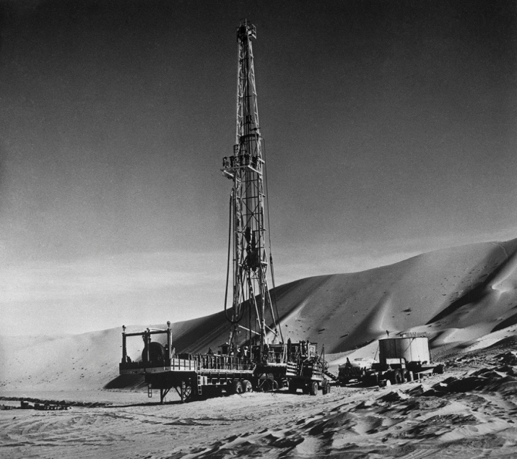
An early Aramco oil rig, circa 1955.
A problem with conspiracy theories—aside from the fact that they always get around to involving “the Jews”—is that they distract us from what’s happening in plain sight.
So, in case you missed it, here’s the biggest thing that happened in the world last week: while our planet was experiencing its hottest month of all time, the earth’s biggest pile of cash (the asset manager Blackrock, with $8.59 trillion dollars under management) named to its board of directors the CEO of the world’s largest oil company, Saudi Aramco, which has produced more carbon emissions than any firm on earth.
This decision was barely even noted—the New York Times produced a nine-paragraph account in its Dealbook newsletter. And yet think of what it means. It is the ultimate signal that the world’s financial community has decided to essentially give up on even the modest commitments they made a couple of years ago in Glasgow, where they said they would work to decarbonize their portfolios.
Two things have happened since they made those big pledges (Blackrock’s Larry Fink said at the time, “we are on the edge of a fundamental reshaping of finance” to deal with the climate crisis). First, the war in Ukraine produced huge profits for the oil industry, as their old pal Vladimir Putin (who once hung a medal around the neck of Exxon’s CEO) pushed the price of petroleum into the stratosphere. And second, the oil industry’s bought-and-paid-for politicians in red-state America wrote nasty letters about “ESG investing” and threatened to break ties with the Wall Street firms that were “going woke.” Those two developments were more than enough to persuade barons like Fink to walk back their professed concern with a planet on fire. He is clearly a go-along get-along guy, and where we’re going is—well, if not hell then someplace with a similar temperature. (So far seven people have died and 85 have been hospitalized in Phoenix simply from burns from touching the pavement). It’s gross when the PGA does business with the murderous Saudi regime; it’s life-or-death for everyone when the biggest business in the world sucks up to the biggest oil company.
So what does stand-up leadership look like? Here’s Brad Lander, the comptroller of New York City. It’s not a sexy job (not like, say, running for president as your first public office). He’s the money guy, balancing the city’s books. But New York City has a lot of money, and that money gives you the power to do useful things that help people. When it got unbearably hot, Lander put out a video pointing out that the big banks the city does business with were still bankrolling the fossil fuel industry. It is straightforward, powerful, plainspoken:
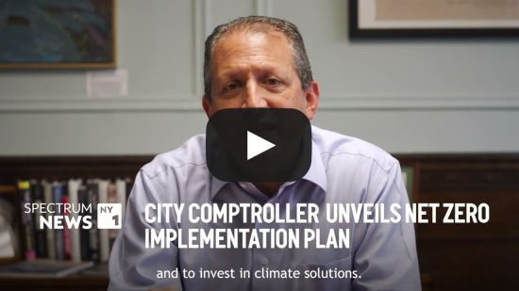
And a few days later, when the Saudi Aramco news came out, Lander was again just about the only public servant I saw react:
“BlackRock has clearly stated that climate risk is an investment risk, but actions speak louder than words,” New York City Comptroller Brad Lander said in an emailed statement. “At a time when financial institutions need to take a collective approach to addressing the financial risks from climate change, BlackRock shareholders expect climate-competent, not climate-conflicted, directors.”
This matters. Blackrock is the largest external money manager for the city of New York. Lander can move that business and it will hurt Blackrock; and his words will at least be heard in the din of Wall Street. Others are starting to figure out just how irredeemable the fossil fuel industry is. Here, for instance, is an editorial in the Los Angeles Times last week that I think is the most forthright declaration ever on Big Oil by a major American newspaper. Forget pretending that the Exxons and Aramcos will ever change their stripes: instead, “kick them to the curb.” I’m going to quote from it at length because the paper’s editorial board was not engaging in the usual tentative to-ing and fro-ing. They just said it:
It should be obvious by now that fossil fuel companies have no real plans to change in response to the climate crisis. And that the only way forward is without them.
Some high-profile environmental leaders have come to a similar conclusion recently, among them influential climate negotiator Christiana Figueres, under whose tenure as executive secretary of the United Nations Framework Convention on Climate Change the landmark 2015 Paris agreement was developed. She wrote in Al Jazeera earlier this month that after years of holding out hope that oil and gas companies would wake up and participate in the decarbonization of the economy, their actions over the last 12 months have changed her mind.
Former Vice President Al Gore, a longtime champion for climate action, has also been speaking with refreshing frankness about fossil fuel industry obstruction, decrying “anti-climate plotting” by companies that refuse to disclose their emissions or commit to phasing them out while they successfully push government policies to slow down the transition to clean energy.
It’s a little late for powerful voices from older generations to come to the realization that fossil fuel companies aren’t operating in good faith and will fight climate action until the bitter end. But it’s welcome nonetheless, and there’s clear generational shift in that direction that offers some hope. Polling last year by the Pew Research Center found that while most Americans are reluctant to ditch fossil fuels, younger adults are much more supportive of phasing out oil, gas and coal entirely.
This is the spirit that we desperately need—the spirit that focuses on the actual, the concrete, the things before our eyes. Like the unbearable heat. Not long before his assassination, Robert F. Kennedy gave a speech at the University of Kansas where he spoke about the real with as much eloquence as any American ever mustered. There was a man who could have been forgiven a conspiracy theory or two—after all, his brother had been killed just five years before. But here’s where he was focused:
Our Gross National Product, now, is over $800 billion dollars a year, but that Gross National Product - if we judge the United States of America by that - that Gross National Product counts air pollution and cigarette advertising, and ambulances to clear our highways of carnage. It counts special locks for our doors and the jails for the people who break them. It counts the destruction of the redwood and the loss of our natural wonder in chaotic sprawl. It counts napalm and counts nuclear warheads and armored cars for the police to fight the riots in our cities. It counts Whitman's rifle and Speck's knife, and the television programs which glorify violence in order to sell toys to our children. Yet the gross national product does not allow for the health of our children, the quality of their education or the joy of their play. It does not include the beauty of our poetry or the strength of our marriages, the intelligence of our public debate or the integrity of our public officials. It measures neither our wit nor our courage, neither our wisdom nor our learning, neither our compassion nor our devotion to our country, it measures everything in short, except that which makes life worthwhile. And it can tell us everything about America except why we are proud that we are Americans.
Brad Lander, born the next year, is heir to that tradition, and so are the editorialists of the Los Angeles Times, and so are all the other Americans who keep their eye on the moment.

In other climate and energy news:
+Here’s a surprise: the fossil fuel industry is cynically using whale activists to block offshore wind turbines. They’re claiming that work on windmills is harming whales; in fact, biologists say warming waters are moving the small fish that some whales feed on closer to shore, and their predator is simply following along, and into the channels of shipping traffic. Here’s Politico’s reporting:
Wind opponents are “just NIMBYs,” said Robert Kenney, a marine biologist who retired from the University of Rhode Island after four decades studying the endangered North Atlantic right whale. “You lie enough and use social media to spread it, and there is a certain group of people who believe it.”
+Joe Romm, venerable climate blogger, has an important paper showing that most carbon offsets are garbage
Carbon offsets are “reductions of greenhouse gas emissions from an activity in one place to compensate for emissions elsewhere,” as the U.S. Government Accountability Office (GAO) put it. In a typical transaction, a developed country or company—instead of reducing its own heat-trapping CO2 emissions—pays a developing country to reduce its emissions by an equivalent amount instead. If the buyer purchases enough offsets to cover all its emissions, then it calls itself “carbon neutral” or “net zero.” Typical projects are deploying clean energy, planting new trees, and paying people not to cut down trees. But research on offsets shows “the large majority are not real or are over-credited or both,” said Dr. Barbara Haya, Director of The Berkeley Carbon Trading Project.
+The wide-ranging veteran reporter Laura Flanders has a nifty broadcast on regenerative farming—she called it “Fighting Racism with Rice,” and it’s very worth a watch.
+Ron DeSantis (R-Several Feet Above Sea Level) may have been distracted by his efforts to show that slavery was a kind of vocational education; something sure took his eye off the ball, because insurance rates in Florida have risen 206 percent since he took office, and are now triple the national average. But never fear, he’s going to sue Budweiser for giving a special can to a transperson, thus forcing him to help launch a boycott that now has cost the state’s pension funds money. So probably Florida will get a lot of money…. In any event, similar hikes in insurance rates may be coming elsewhere: Travelers reports that losses due to harsh weather doubled last year
+As You Sow, which sponsors shareholder pressure campaigns, reports that their efforts to convince Amazon to use less plastic packaging seem to be working.
In 2022, Amazon used 85,916 metric tons of single-use plastic to ship orders to customers, an 11.6% decrease from 97,222 metric tons in 2021, the company stated in its sustainability report released on Tuesday.
+The fossil fuel industry, in its constant effort to keep burning things, wants the federal government to help them ‘certify’ fracked gas as clean because they’ve begun to staunch the methane leaks they let pour into the atmosphere for decades. Climate justice groups are not having it.
A group of nearly 150 environmental justice groups urged the Biden administration on Wednesday to abandon talks with global energy companies on standards for certified natural gas, a form of the fuel that producers market as climate friendly, but that critics say undermines the transition from fossil fuels.
The Natural Resources Defense Council, Sierra Club, Gas Leaks and other green groups argued the discussions are a diversion from President Joe Biden's pledge to move toward cleaner energy sources and endanger public health.
"While we strongly support robust and well-enforced regulations to cut methane leaks from the oil and gas sector, we oppose efforts that aim to provide 'extra credit' which the gas industry uses to promote growth in the production, trade and consumption of methane gas," they wrote in a letterto U.S. Energy Secretary Jennifer Granholm.
+James Hansen, the scientist who more than any other woke the world up to climate change, has been telling it like it is since 1988. Thirty five years later, watching the planet overheat, he told reporters that we’ve been “damned fools” to ignore warnings:
“There’s a lot more in the pipeline, unless we reduce the greenhouse gas amounts,” Hansen, who is 82, told the Guardian. “These superstorms are a taste of the storms of my grandchildren. We are headed wittingly into the new reality – we knew it was coming.”
+Imagine being in an un-air-conditioned prison during this summer’s heat waves. The Prison Policy Initiative has run the truly horrifying numbers:
An extreme heat day (one that falls within the hottest 10% of days for a particular location) was associated with a 3.5% increase in deaths. These extremely hot days had a delayed effect on suicides, which increased by 23% over the three days that followed. As if prison environments weren’t already damaging enough to mental health, the oppressive heat and a prison’s failure to provide relief from it can drive someone into unbearable distress.
+A little good news from down under, where Australia’s banks have refused to loan money to the country’s biggest pure-play coal miner for expansion of its facilities. “There’s no doubt that some of the banks have chosen not to participate in the refinancing as we go forward. Thermal coal has been less appealing from the bank’s perspective in terms of how they want to decarbonise their lending portfolios,” a spokesman told the Sydney Morning Herald
+From the Brushwood Center, a fascinating report on access to nature in Lake County Illinois
Lake County is home to beautiful green and blue spaces including Lake Michigan, park districts, county forest preserves, state parks, rivers, and spaces created by grassroots groups. Yet, despite this natural abundance, there are barriers to accessing the outdoors. Nearly half of Black/African American respondents and 31% of Hispanic respondents express access, safety, or maintenance concerns to visiting parks or open spaces versus 21% of White respondents (Figures 12-14). Interviewees identified numerous barriers to accessing nature, including limited transportation options, lack of materials in Spanish, cold weather, and a need for more culturally relevant nature-based programs, providers, and partnerships.
+It’s going to be harder and harder to compete with the low price of green electricity. Here’s the story of a French city that ordered 51 hydrogen buses, and then cancelled the order when it turned out electric buses would be…six times cheaper to run
+Many thanks to all who have written in to inquire about how things are going in flood-soaked Vermont. A little better, though the rains of July have kept coming. But here’s an insightful account from Anne Galloway (founder of Vermont Digger, the state’s digital news source, which really reached a new level with coverage of the floods) about the ways in which the recovery from Hurricane Irene in 2011 helped cushion this summer’s blow a little. FEMA broke with tradition and let Vermont use federal money to improve bridges, not just rebuild them. This storm was bigger, but the damage was smaller:
Officials with VTrans, the Vermont Agency of Transportation, are in the process of assessing the damage, but as of yesterday, there were 29 road closures, down from 78 on Tuesday as in just 24 hours VTrans made temporary fixes to state highways. Nine bridges were washed out—just 5 percent of the number impacted by Irene. A new state office building built in 2014 was surrounded by floodwater, but the facility was high and dry.
On Wednesday, during a press conference with state officials, FEMA Administrator Deanne Crisswell told Vermont reporters that the agency now sees climate change as a factor. “We need to better understand what it’s going to look like 10, 20 years from now so we can use our mitigation dollars to help reduce impacts,” she said. (Ironically, the state only four months ago closed out its last FEMA filing for Irene).

