Why Oil Stocks Aren’t That Hot
We explore some of the patterns investors track to help understand what they show.
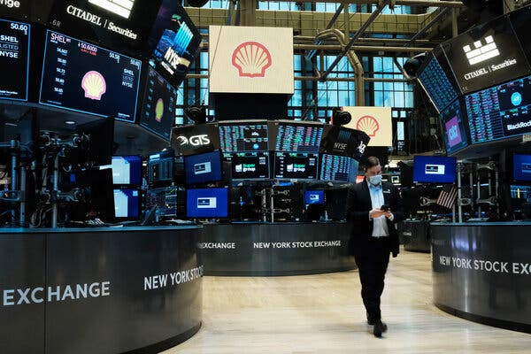
Credit...Spencer Platt/Getty Images
By Manuela Andreoni, Feb. 22, 2024
You’re reading the Climate Forward newsletter, for Times subscribers only. News and insights for a warming world.

Oil companies have recorded hundreds of billions of dollars in profits. Investment firms have backtracked their climate commitments. High interest rates are hurting clean energy companies.
The world of finance doesn’t seem to have been too kind to the global pledge to transition away from fossil fuels lately. For investors, has the golden age of oil profitability returned?
Not really.
Flattening out the ups and downs of the recent years (and there have been many), fossil fuel companies haven’t actually done that well in the past decade when compared with other major corporations. A study published this month by the Institute of Energy Economics and Financial Analysis, an Ohio-based think tank, found that stock-price indexes (or broad baskets of stocks) that excluded the fossil fuel industry performed slightly better than those that didn’t in the past decade.
A 2023 report from Columbia University’s Center on Global Energy Policy also found that oil and gas companies have underperformed in the longer term when compared to the S&P 500, an index that’s often used as a benchmark by investors.
That’s a reversal from the previous years, the researchers say, when the oil and gas industry mostly outperformed these indexes.
Does that mean that the energy transition is slowly chipping away at carbon-rich profits? Perhaps, but that’s not the full story. Today I want to take you through some of the patterns investors track, to help you understand what they show.

A bumpy road
Fossil fuel companies are facing increasing competition from clean energy. But demand for energy, especially in the developing world, is growing, too. How will these two forces stack up in the future?
No one knows.
What the numbers show so far, recent record profits but a longer term underperformance in stock prices, is subject to interpretation.
Tom Sanzillo, the director of financial analysis at IEEFA, told me that what we are seeing is a decline of the fossil fuel industry. “This is a fundamental change,” he said. “And it’s going to continue.”
Gautam Jain, a senior research scholar at Columbia who focuses on energy markets, feels that it’s a bit more complicated than that. The energy transition does seem to have had a role in declining fossil fuel stock prices, he said, because changing energy policies and greater desire for cleaner alternatives make demand for their product uncertain.

Latest News on Climate Change and the Environment
- Amazon rainforest. Up to half of the Amazon rainforest could transform into grasslands or weakened ecosystems in the coming decades, a new study found, as climate change, deforestation and severe droughts damage huge areas beyond their ability to recover. Those stresses in the most vulnerable parts of the rainforest could eventually drive the entire forest ecosystem past a tipping point that would trigger a forest-wide collapse, researchers said.
- A significant threshold. Over the past 12 months, the average temperature worldwide was more than 1.5 degrees Celsius, or 2.7 degrees Fahrenheit, higher than it was at the dawn of the industrial age. That number carries special significance, as nations agreed under the 2015 Paris Agreement to try to keep the difference between average temperatures today and in preindustrial times to 1.5 degrees Celsius, or at least below 2 degrees Celsius.
- New highs. The exceptional warmth that first enveloped the planet last summer is continuing strong into 2024: Last month clocked in as the hottest January ever measured, and the hottest January on record for the oceans, too. Sea surface temperatures were just slightly lower than in August 2023, the oceans’ warmest month on the books.
- A revised history. Scientists have examined the chemical composition of the skeletons of centuries-old spongy sea creatures living in the Caribbean Sea to piece together a new history of the earliest decades of global warming. The research points to a startling conclusion: Humans have raised global temperatures by a total of about 1.7 degrees Celsius, or 3.1 Fahrenheit, not 1.2 degrees Celsius, as widely suggested until now.
- A giant parasol in outer space? With Earth at its hottest in recorded history, and humans doing far from enough to stop its overheating, a small but growing number of astronomers and physicists are proposing a fix that could have leaped from the pages of science fiction: the equivalent of a giant beach umbrella, floating in outer space.
But there were other, more direct, hits to their profits. In the early 2010s, the shale revolution allowed companies to extract oil and gas much more cheaply, sharply reducing prices and, with them, oil profits. Then, just as the industry was stabilizing, the pandemic struck, shattering demand for oil as billions of people across the world locked themselves inside for months.
The recent bump in profits, after Russia’s invasion of Ukraine, gave companies an opportunity to reward their investors after years of bad returns, he said. In 2022, companies announced tens of billions of dollars in stock buybacks, which is when a company buys its own shares in the open market. Buybacks, which often happen when a company believes its stock is undervalued, can increase the price of the stock. That of course benefits investors already holding the stock.
It’s telling, Jain said, that companies chose that path rather than to invest more of their profits in producing more oil and gas. “They understand that the demand is uncertain going forward,“ Jain said.
Uncertainty about the future means companies don’t know how much oil and gas they should produce to meet the world’s needs. That will quite likely result in a bumpy road for prices, as they adjust to the changing economy in real time.
Still, Jain’s research at Columbia also shows that, despite all these concerns, borrowing costs haven’t increased for oil and gas companies. Financial institutions don’t seem to be scared that oil companies won’t be able to pay them back.

Governments lead the way
Making smart investment decisions is mostly about understanding what will make money in the future. That has become very difficult in energy markets as the world transitions to cleaner sources of power.
I wanted to understand how investors who are concerned about the economic risks of climate change are thinking about this. I called Liz Gordon, who oversees corporate governance at the New York State Common Retirement Fund, to ask why the pension fund had decided to restrict its investments in Exxon and other fossil fuel companies, a move it announced last week. (The fund still holds Exxon shares, but through investments like index funds as opposed to purchases of Exxon stock directly.)
She told me that, despite all the uncertainties, the fund sees a clear signal that policies going forward will very likely hurt the profits of companies that aren’t prepared to transition to a low carbon economy. “You’ll see an increasing price on carbon or other types of regulatory actions that will drive change and will make emitting greenhouse gases more expensive,” she said.
That’s a key message I heard from several experts. In a world of unknowns, policy has become a guide in the moneymaking labyrinth of the future.
It’s clear, though, that oil companies and investors believe there will be fossil fuels well into the future. Jian’s research shows that oil and gas investments aren’t aligned with a world in which nations stop adding carbon dioxide to the atmosphere by 2050, which is what scientists say is imperative to avoid the most catastrophic impacts of climate change.
But they are consistent with the pledges by countries to lower their carbon emissions, he added. Whatever countries decide to do going forward, private money will probably follow.
“Policy is actually much more powerful than you think,” Jain told me. “Nobody can predict when the actual demand will peak. But they can see the impact of policy.”

